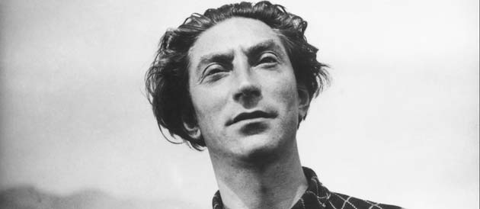

**http://zakhor-online.com/wp-content/uploads/2013/07/Benjamin-Fondane.jpg**

**Fondane, Benjamin (1898 – 1944)**

A primarily francophone Jewish poet and writer of Romanian origin, Fondane became known as a critic, poet and dramaturge in Romania before leaving Bucharest for France in 1923.In Paris, he mixed with the avant-gardes of the 1920s both as a poet and as a critic and philosopher of cinema. An admirer of René Clair and Man Ray, he emphasised the liberating and transgressive possibilities of silent cinema and became first a scriptwriter and then a director, shooting the avant-garde film *Tararira* in Argentina in 1936. He became close to the Dadaists, the Grand Jeu group (Roger Gilbert Lecomte, René Daumal) and dissident Surrealists. He also represented the Romanian avant-garde in Paris with the magazine *Intégral* and wrote a remarkable essay on Constantin Brancusi’s sculpture in 1929.

From 1929, Fondane became a spokesperson for the philosophy of Leon Shestov, promoting it to a wide audience in his column “La philosophie vivante” [“Living Philosophy”] in the *Cahiers du Sud* and in *La Conscience malheureuse* [*The Unhappy Consciousness*, 1936]. In this essay, Fondane re-affirmed the radical antagonism posited by Shestov between the logos and existence, between Athens (reason) and Jerusalem (faith). Fondane became one of the most respected representatives of the existential philosophy which preceded Jean-Paul Sartre’s existentialism. His philosophical dialogue with Edmund Husserl, Martin Heidegger, Jacques Maritain, Jean Wahl, Albert Camus and Rachel Bespaloff is fundamental for understanding the stakes of these later debates. An adversary of Husserlian phenomenology, he asserted the rights of the individual and drew on Pascal, Nietzsche, and Kierkegaard. His interdisciplinary body of work (cinema, poetry, theatre, philosophy, criticism) expressed a cry of revolt against the excesses of rationalism and all forms of negation of the individual. His essays on history converge with themes considered by Walter Benjamin and T. W. Adorno. His last essay, “Le Lundi existentiel et le Dimanche de l’histoire”[“Existential Monday and the Sunday of History”]*,* a veritable philosophical testament, commissioned by Jean Grenier and finished a few days before his arrest, approaches the “catastrophic” consequences of Shestov’s philosophy for the theory of history.

In his long poems *Ulysses* (1933), *Titanic* (1938) and *L’Exode* (pub. 1965). Fondane tackles themes of rupture, forgetting, exile and catastrophe, often interwoven with traditional Jewish motifs. He was one of the first to apply Shestovian philosophy to literary and poetic criticism, in *Rimbaud le voyou* [*Rimbaud the rogue*, 1933], *Faux Traité d’esthétique* [*False Aesthetic Trewaty*, 1938] and his posthumous work *Baudelaire et l’expérience du gouffre* [*Baudelaire and the Experience of the Abyss*, 1947], which develops an anti-platonic aesthetic, certain aspects of which invite comparison with the poetics of Yves Bonnefoy. He was arrested in Paris on the 7th of March 1944 and deported to Auschwitz, where he died on the 2nd or 3rd of October.

List of works

*Rimbaud le voyou,* Paris : Denoël, 1933. New edition : *Rimbaud le voyou et l’expérience poétique* (1990) Bruxelles: Editions Complexe.

*La Conscience malheureuse*, Paris : Denoël, 1936. Critical edition, ed. Olivier Salazar-Ferrer et Nicolas Monseu, Paris: Verdier, 2013.

*Faux Traité d’esthétique* Paris : Denoël : 1938. New edition : Paris : Paris-Méditerranée, 1998.

Posthumous publications

*Baudelaire et l’expérience du gouffre: Préface de Jean Cassou* (1947).

*Le lundi existentiel* (1990). Paris: Editions du Rocher.

*Le mal des fantômes* (2006) ed. Patrice Beray, Michel Carassou. Paris: Editions Verdier.

*Ecrits pour le cinéma: Le muet et le parlant* (2007) ed. Olivier Salazar-Ferrer et Ramona Fotiade, Paris: Verdier.

**Further reading**

Olivier Salazar-Ferrer, *Benjamin Fondane*, Paris :Oxus, 2004.

Ramona Fotiade, *Conceptions of the absurd* *– From Surrealism to Chestov’s and Fondane’s Existential Thought*, Oxford : Legenda, 2001.

Olivier Salazar-Ferrer, *Benjamin Fondane et la révolte existentielle*, Paris : De Corlevour, 2007.

Michael Finkenthal, *Benjamin Fondane – A poet-Philosopher caught between the Sunday of History and the Existential Thought,* New-York : Peter Lang, 2013.

Luca Orlandini, *La Vita Involontaria – In margine al Baudelaire e l’esperienza dell’abisso di Benjamin Fondane*, Torino: Nino Aragno, 2013.

Website : [www.benjaminfondane.org](http://www.benjaminfondane.org)

Olivier Salazar-Ferrer (University of Glasgow)

Andrew Rubens (University of Glasgow)